Direct comparison of the fibre break development in unidirectional carbon fibre composites under tension predicted by
statistical models and measured using 4D in-situ SRCT

Christian Breite^{1*}, Francisco Mesquita¹, Larissa Gorbatikh¹, Stepan V. Lomov¹ and Yentl Swolfs¹

¹Department of Materials Engineering, KU Leuven, Kasteelpark Arenberg 44 – box 2450, Heverlee, 3001, Belgium, christian.breite@kuleuven.be, francisco.mesquita@kuleuven.be, larissa.gorbatikh@kuleuven.be, stepan.lomov@kuleuven.be, yentl.swolfs@kuleuven.be

Abstract:
While progress has been made in the development of fibre break models for the simulation of the longitudinal tensile strength of unidirectional composites, the complex physics leading to final failure have not been fully understood yet. Especially the influence of fibre strength distribution and matrix plasticity on the fibre break accumulation seems to be a missing link. A direct comparison between modelled and in-situ measured fibre break development covering different fibre matrix combinations is needed to assess the chosen modelling approach.
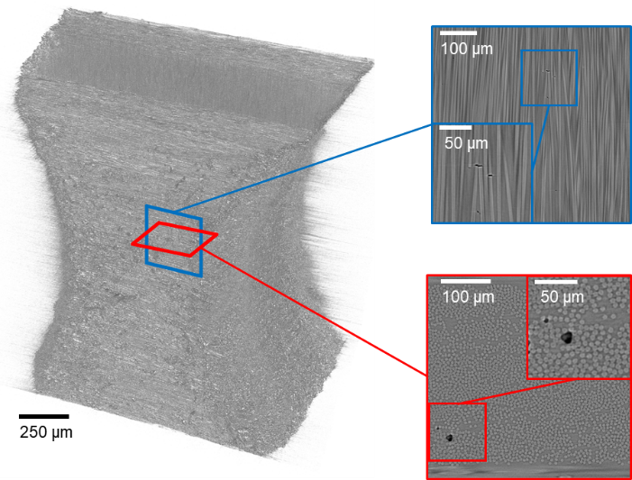
Experiments were carried out under continuous loading using ultrafast synchrotron computed tomography (9 s per volume) at the TOMCAT beamline of the Swiss Light Source. Image analysis on the resulting high resolution images (see fig. 1) was conducted using automated image analysis tools developed in-house as well as employing the InSegt tool box for individual fibre segmentation [1]. The dataset presented in this study comprises of several similar carbon fibres in composites: T700SC, T300 and 34-700WD. The matrix polymers are epoxy resins with similar T_{g}, strengths and stiffnesses The fibre strength distributions have been directly measured using the in-situ tracked fibre breaks and the resin systems have been characterised by a combination of tensile and compressive tests.
By comparing the obtained virtual and experimental results, the study answers fundamental questions important for the selection of a material system: How do fibre strength distribution parameters affect the composite strength? Is the physics-based fibre break model able to capture trends observed in experiments for different material combinations? What challenges exist and how can we further improve the models in the future?
Fig. 1: Rendering of 3D CT volume with indications for longitudinal and transverse slices in the 0° plies of the cross-ply specimen; blue: longitudinal slice containing a non-coplanar fibre break cluster; red: transverse slice containing a coplanar fibre break cluster

Acknowledgements:
The research leading to these results has been conducted in the framework of the FiBreMoD project and has received funding from the European Union’s Horizon 2020 research and innovation programme under the Marie Skłodowska-Curie grant agreement No. 722626. The support of C. Schlepütz from TOMCAT beamline at Swiss Light Source for optimising the acquisition settings during the beamtimes under proposal IDs 20161157 and 20171494 is thankfully acknowledged.

[1] Emerson MJ, Jespersen KM, Dahl AB, Conradsen K, Mikkelsen LP. Individual fibre segmentation from 3D X-ray computed tomography for characterising the fibre orientation in unidirectional composite materials. Composites Part A: Applied Science and Manufacturing. 2017;97:83-92.

